Schedule
9th International Combined Marathon Cheb 2021
05th June – 06th June 2021

Promoter: TJ MG Cheb (Czech Republic)
Tournament director: František Nečekal jun.
Referees and Jury: provided by promoter
Course location: Minigolf course TJ MG CHEB, Břehnická 19, Cheb, Czech Republic
Course type: Miniaturegolf + Concrete
Categories: Team competition: 4-member teams (each round counts 3 best results)
Individual competition: Absolute women, Absolute men
Scheme of tournament: Double-rounds miniaturegolf + concrete (according to official rules of Czech Minigolf Federation and WMF)
Registration: Until 04th June 2021 to: František Nečekal jun., info@tjmgcheb.cz
Accommodation and other information: www.tjmgcheb.cz
Training fee: free of charge, Friday without public players and free of charge
Participation fee: 20€ / player (lunch on Saturday and Sunday included)
Fees have to be payed till 04th June 2021 18:00
Prizes: Cups and other valuable prizes for first 3 teams, 10 individual men and 5 women
Every player gets a participation prize
Financial prizes in a lottery – min. 1x 5x 1000 CZK
Lunch and refreshment: directly on the course
Schedule: Friday, 04th June 2021
18:00 opening ceremony
drawing of groups (2 or 3 players in one group)
Saturday, 05th June 2021
08:00 – 19:00 double-rounds
12:00 – 13:00 lunchtime
Sunday, 06th June 2021
08:00 – 14:00 double-rounds
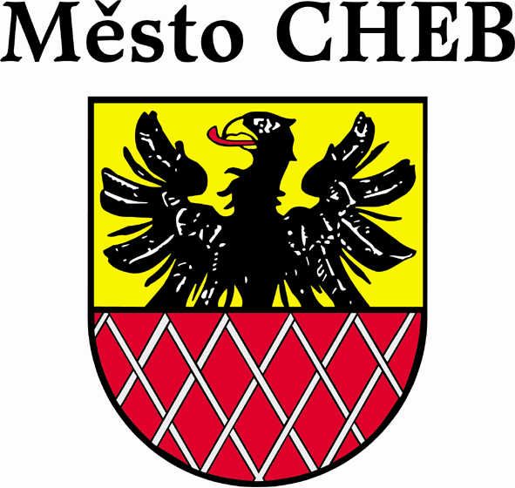
14:00 lunchtime
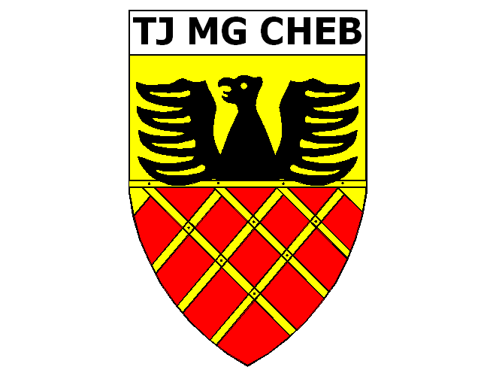
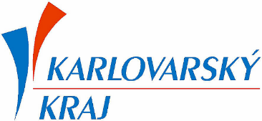
15:30 closing ceremony

